**Grocery Automation System**

**1. Information Gathering**

Following are outputs of surveys we did before start working on project. For survey we asked following question to the grocery shop owner. For survey, we visited to 5 local grocery shop.

1. **How grocery shop sells their products?**

Local grocery shops don’t have any delivery system. Customer physically need to go to grocery shop to buy the groceries they want. We come to know that local grocery shops have customer in 2km. circle.

1. **How they manage their inventory?**

Some of grocery shops have their godown (Small Warehouse). They normally use book to manage product they have. Whenever the stock of some product is less, they order the same from different vendors. For that they have list of their merchants.

1. **How they manage customers information?**

Usually, the grocery shop doesn’t use to have any information about the customer.

1. **Did they used online way to sell their products in pandemic?**

Lots of grocery shop don’t use to have their business on internet. But some of them sell their product on WhatsApp or on mobile phone. These shops also have home delivery. For that they have hired delivery boy to deliver the products. For home delivery they are taking some cost.

So, this is information that we have gathered in our survey. This information really helps us to build our initial project model.

**2. Module diagram for Project**

Conceptual diagram of our project.

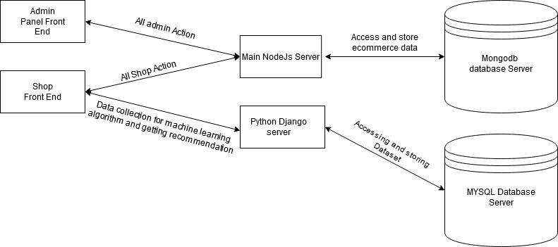

**3. Technology Stack**

